EMOTIONAL ARCHETYPES DIAGNOSTIC

Introduction:
We all have defaults with our emotions unless we choose to step into choice. Our emotional archetypes are our default when under pressure. When under pressure we respond from our unconscious. It is where our old patterns exist. Emotional archetypes are a pattern of emotional responses and tend to be created for safety at a point in time, even though they may not serve us in the here and now.

These emotional archetypes are often interpreted as who you are – your identity – a fixed position and you can become passive in your relationship with your emotions as a result. The model can be a helpful way to offer a new perspective and enable a shift into new possibilities and a new relationship with your emotions.

They are also a framework which can help you to understand your current relationship with your emotions. The model offers the insight that you have the opportunity to step outside of your patterns into choice.

Emotional Archetypes Model:

There are four dimensions to the model, four archetypes. Each are a starting point for raising emotional self awareness and response-ability.

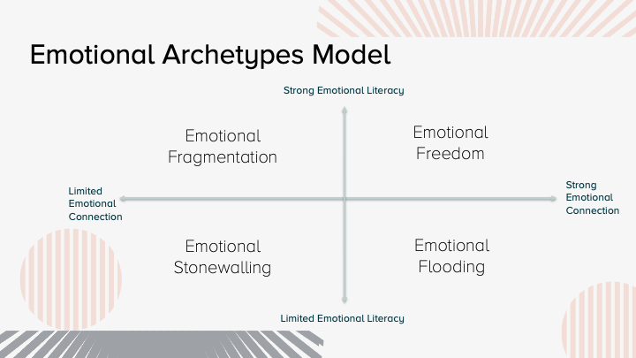

There are two axis in the model:
Emotional literacy is the ability to use language to articulate emotions and understand it. It is also the ability to understand and explain more about the emotion, for example:
- How it feels to feel that
- The impact on you
- What your need is
The second axis emotional connection is references the ability to:
- Be in full contact with your emotions
- To connect the relationships between your emotions
- Be able to experience the full range of emotions
- To accept your emotions
The Questionnaire
The questionnaire is a self assessment which will provide an indication of which of the four emotional archetypes may be your default. With this knowledge you can learn more about your current reality and make a plan to achieve emotional freedom if it’s not your current archetype.
Completing the questionnaire
Please read each statement and tick whether you agree or disagree with it.
EMOTIONAL ARCHETYPE INDICATORS
No. | STATEMENT | AGREE | DISAGREE
1 | I view all my emotions as equal – I do not label different emotions as good or bad
2 | I can become silent about my emotions verbally, but physical signs show.
3 | I find a lack of emotional connection in relationships and I can be difficult to get to know
4 | I can be impatient with others who I see as ‘emotional’
5 | I am comfortable asking others about their emotions and people share emotions with me as they feel safe in my company
6 | I often take on more than I can realistically do and feel unappreciated
7 | I sometimes find it difficult to connect with others who are more in tune with their emotions
8 | I am comfortable sharing my emotions in an appropriate way
9 | Emotions are in control of me rather than me being in control of my emotions
10 | I can be quick to judge others for lack of resilience
11 | I fear being overwhelmed by my emotions
12 | I hide my emotions, therefore I am often overlooked when I am in a time of need
13 | I withdraw under stress/pressure as it feels too much to cope with
14 | I am able to identify and accept my emotions, without pushing them away
15 | I don’t always recognise the need for help or ask for help when I need it
16 | I am emotionally resilient
17 | I feel lonely when others do not seek a deeply connected relationship with me
18 | I feel that I lack effective coping strategies when I experience multiple emotions
19 | I can describe my emotions, but I don’t allow myself to feel them.
20 | People can mistake me for lacking resilience because emotions often leak out
21 | I recognise my emotions as valuable to me
22 | I have a low tolerance for listening to others emotions
23 | I can be taken advantage of because I am attentive to the needs of others
24 | I expect myself and others to be able to cope in all circumstances

SCORING
Please now circle the question numbers you agreed with in the table below. Then total up each column. This will give you a total at the bottom and show which emotional archetype is most likely to be your default when under stress.

 | Emotional Freedom | Emotional Fragmentation | Emotional Stonewalling | Emotional Flooding
 | 1 | 4 | 3 | 2
 | 5 | 7 | 6 | 9
 | 8 | 10 | 13 | 11
 | 14 | 12 | 15 | 17
 | 16 | 19 | 18 | 20
 | 21 | 24 | 22 | 23
Total circled

Please find below a detailed description of each of the emotional archetypes paying particular attention to the emotional archetype that had the biggest score for you in the table above. The highest score suggests that this may describe your relationship with your emotions currently. It is always possible to change your relationship with your emotions and an Emotions Coaching Practitioner™ coach can support you with this.
Emotional Freedom
The individual who experiences the emotional freedom archetype is deeply connected to their emotions and has the emotional literacy and courage to express their internal experience to others in a healthy way. They have the ability to regulate their emotions because they can notice them and process them in a helpful and balanced way. These individuals have the skills to help themselves be understood. They recognize their needs and advocate for them. Emotions are recognised and valued as information, data to help them understand what they want and need. The emotional freedom archetype is great at building and maintaining relationships due to their high empathy skills.
Benefits of emotional freedom:
- Being able to choose your emotions is important for so many reasons.
- It nurtures confidence in your emotions
- It empowers you with your emotions
- It supports your emotional wellbeing
- It generates new options for perspective and actions
- It facilitates emotional resilience
- It enables you to experience your full emotional range. What we mean by this is all the emotions that it is possible for a human to experience.

Emotional Fragmentation
The individual who experiences the emotional fragmentation archetype is disconnected from feeling their emotions, but they are able to express them cognitively. They keep emotions at arms length and they avoid allowing themselves to ‘feel’ their emotions. They may talk dispassionately or descriptively about their emotions but rarely let those emotions in. The emotional fragmentation archetype is less able to regulate themselves when their emotions are unfamiliar or they’re experiencing several emotions happening at once. Emotions that can’t be embodied build up and create additional emotions such as confusion, frustration and overwhelm. The emotional fragmentation archetype may think they are emotionally aware, but in fact they are protecting themselves from experiencing the emotions they think they are having. This can lead to disconnection in relationships, being misunderstood or being experienced as ‘cold’.
Emotional Stonewalling
The individual who experiences the stonewalling archetype is disconnected from feeling their emotions and lacks the courage or vocabulary to express their emotional experience. This archetype is largely unaware of their day to day emotions or emotional needs. The stonewall archetype tend to ‘push emotions under the carpet’ and prioritise other needs such as action over their feelings. Little value is placed in ‘feeling’ emotions or they do not feel safe to allow themselves to do so. The problem facing this archetype is that emotions build up over time and eventually the damn bursts and at this point there is a risk that they do not have the skills or vocabulary to navigate this period of life without difficulty. At this point they feel out of control and embarrassed. They can be difficult to get to know or relate to because they look like they are not experiencing any emotions. They can also feel unappreciated by others.
Emotional Flooding
The individual who experiences the emotional flooding archetype is deeply connected to their emotions but lacks the ability to express what they are feeling from one moment to the next. This archetype is often overwhelmed by their emotions because they have no means through which to express their inner experience. The emotional flooding archetype often feels misunderstood because they find it hard to understand their emotional experience. Emotions become frightening for this archetype which exasperates the overwhelm. The problem facing this archetype is that they can feel trapped in their inner experience and can feel ashamed of their emotional experience. When in an emotionally intense experience they may try to escape it or they may avoid putting themselves forward for situations that may invoke a strong emotional experience for them.

